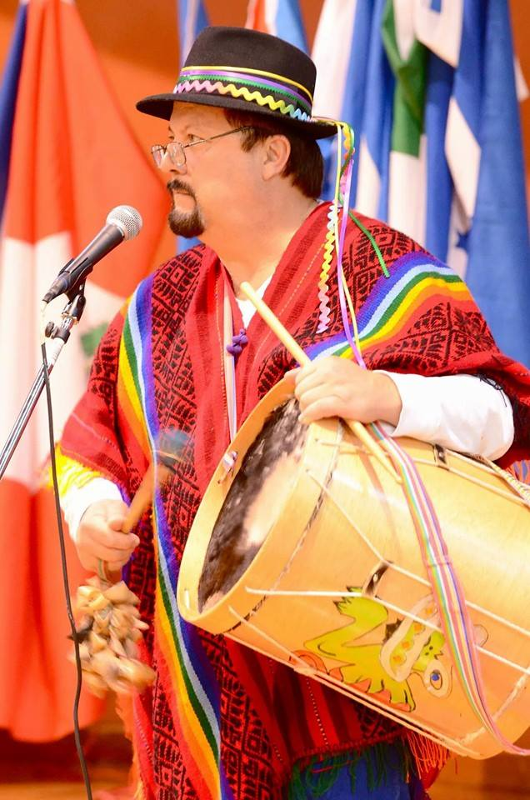

CALL TO ARTISTS FOR FIESTA CULTURAL
Entry deadline: Friday, July 31st
Entry fee: None
Also available at www.lanearts.org/fiesta-cultural
Lane Arts Council presents Fiesta Cultural, a celebration of Latino culture, art, and heritage during the month of September. Visual artists are needed for both gallery and art venue exhibits, as well as open air displays in prominent locations during four Art Walks (weather permitting). Submitted artwork must be created by Latino artists, or be related to Latino culture or heritage. All mediums are welcome.
Participating Art Walks include:
First Friday ArtWalk in Downtown Eugene (9/4)
Second Friday Art Walk in Downtown Springfield (9/11)
Second Saturday South Willamette Art Walk in Eugene (9/12)
Last Friday Art Walk in Cottage Grove (9/25)
The Art Walk committee will determine which artwork is displayed where, based on need and space. The more flexibility artists have regarding date availability, the better chance of selection.
Applicants are required to 1) fill out the brief form below and 2) submit images, including details such as title, dimensions, and medium (information can be included in the image file name or on a separate page) to artwalk@lanearts.org. Applicants can submit up to 10 images, however, not all may be exhibited. Each image should be less than 1 MB.

Submission form for Fiesta Cultural

Name: Click here to enter text.

Email: Click here to enter text.

Phone: Click here to enter text.

Address: Click here to enter text.

Website (if applicable): Click here to enter text.

# of pieces available: Click here to enter text.

Medium(s): Click here to enter text.
Select all dates are you available (participation may require same day set up and take down)
September 4th, First Friday ArtWalk in Downtown Eugene ☐
September 11th, Second Friday Art Walk in Downtown Springfield ☐
September 12th, South Willamette Second Saturday Art Walk in South Eugene ☐
September 25th, Last Friday Art Walk in Cottage Grove ☐

Please submit up to 10 images to artwalk@lanearts.org. Include the title, size of artwork, and medium for each image, either in the file name or on a separate sheet. Each image should be less than 1 MB. If you do not have access to email, special accommodations can be made. Please call 541.485.2278 for more details.
Images and forms are due by Friday, July 31st. Submissions received after this date may not be eligible for all of the Art Walks.

